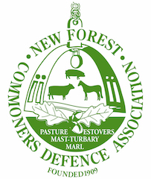

Presentment to the Verderers Court, May 2020

Tony Hockley, Chairman of the New Forest Commoners Defence Association.

The CDA asks the Verderers urgently consider holding the monthly Open Court online whilst the Coronavirus restrictions on public gatherings remain in place.

For many of us the monthly Open Court plays an important role in the life of the New Forest. The current arrangement whereby announcements and presentments are simply placed on the website in the days following each Court date seems a very poor alternative. There is no good substitute for a live event, when everyone has access to the same information, at the same time, including the capacity to make planned or impromptu presentments.

Voluntary and statutory organisations across the New Forest, our own included, have adapted to online video meetings, many are open to the general public to watch or engage. I am confident that we or any of the other partner organisations would be very willing to assist the Court in establishing a suitable arrangement.

This is an opportunity for the Court to raise its visibility and accessibility, demonstrating its value to the New Forest. Our worry is that the lack of any apparent attempt to maintain the practice of an Open Court, despite ready means to do so, does the opposite. This risks undermining its status.

We look forward to the day when we shall be able to once again participate in the Open Court in person. We trust that the Verderers are making plans as to how this might be done safely, when regulations permit the resumption of such activities.

